AT89c51 Micro Controller

The ISSI IS89C51 is a high-performance microcontroller fabricated using high-density CMOS technology. The CMOS IS89C51 is functionally compatible with the industry standard 80C51 microcontrollers. The IS89C51 is designed with 4-Kbytes of Flash memory, 128 x 8 RAM; 32 programmable I/O lines; a serial I/O port for either multiprocessor communications, I/O expansion or full duplex UART; two 16-bit timer/counters; an six-source, two-priority-level, nested interrupt structure; and an on-chip oscillator and clock circuit. The IS89C51 can be expanded using standard TTL compatible memory.

Packages available:
- 44-pin PQFP
- 44-pin PLCC
- 40-pin DIP

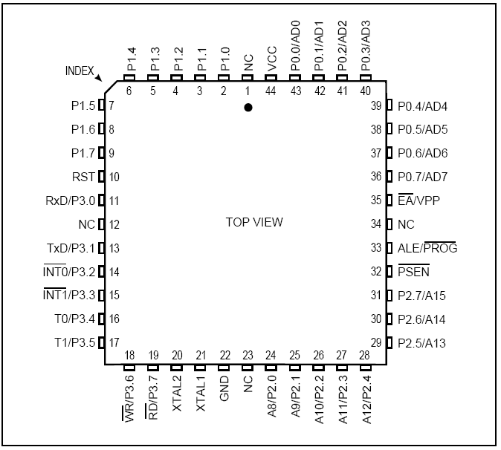
Figure 1 - 89C51 Top View

The AT89C51 provides the following standard features: 8K bytes of Flash, 256 bytes of RAM, 32 I/O lines, three 16-bit timer/counters, six-vector two-level interrupt architecture, a full duplex serial port, on-chip oscillator, and clock circuitry. In addition, the AT89C51 is designed with static logic for operation down to zero frequency and supports two software selectable power saving modes. The Idle Mode stops the CPU while allowing the RAM, timer/counters, serial port, and interrupt system to continue functioning. The Power down Mode saves the RAM contents but freezes the oscillator, disabling all other chip functions until the next hardware reset.

Features of 89c51 micro controller,
- 80C51 based architecture
- 4-Kbytes of on-chip Reprogrammable Flash Memory
- 128 x 8 RAM
- Two 16-bit Timer/Counters
- Full duplex serial channel
- Boolean processor
- Four 8-bit I/O ports, 32 I/O lines
- Memory addressing capability
- 64K ROM and 64K RAM
- Program memory lock
- Lock bits (3)
- Power save modes: Idle and power-down
- Six interrupt sources
- Most instructions execute in 0.3 ms
- CMOS and TTL compatible
- Maximum speed: 40 MHz @ Vcc = 5V
- Industrial temperature available

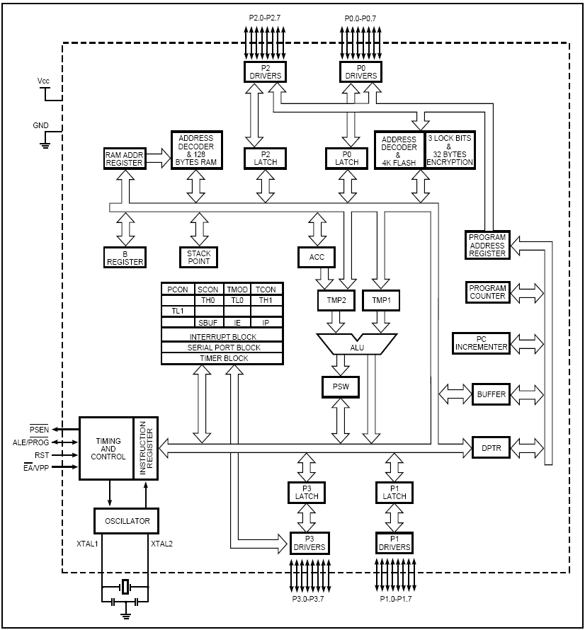
Figure 2 - 89C51 Block Diagram

Pin Description

Port 1 – Pins 1 – 8

Port 1 is an 8-bit bidirectional I/O port with internal pullups. The Port 1 output buffers can sink/source four TTL inputs. When 1s are written to Port 1 pins, they are pulled high by the internal pullups and can be used as inputs. As inputs, Port 1 pins that are externally being pulled low will source current (IIL) because of the internal pullups. In addition, P1.0 and P1.1 can be configured to be the timer/counter 2 external count input (P1.0/T2) and the timer/counter 2 trigger input (P1.1/T2EX), respectively, as shown in the following table. Port 1 also receives the low-order address bytes during Flash programming and verification.

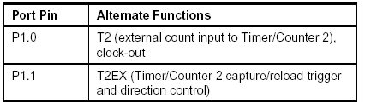
Table 1 – Port1 Pin details

RST – Pin 9

Resets the input. A high on this pin for two machine cycles while the oscillator is running resets the device and clears all registers. Bringing this pin back to logical state zero starts the program anew as if the power had just been turned on. In another words, positive voltage impulse on this pin resets the Micro controller unit. Depending on the device's purpose and environs, this pin is usually connected to the push-button, reset-upon-start circuit.

Port 3 – Pins 10 – 17

Port 3 is an 8-bit bidirectional I/O port with internal pullups. The Port 3 output buffers can sink/source four TTL inputs. When 1s are written to Port 3 pins, they are pulled high by the internal pullups and can be used as inputs. As inputs, Port 3 pins that are externally being pulled low will source current (IIL) because of the pullups. Port 3 also serves the functions of various special features of the AT89C51, as shown in the following table. Port 3 also receives some control signals for Flash programming and verification. Each pin of Port 3 has an alternative function, shown in table below.

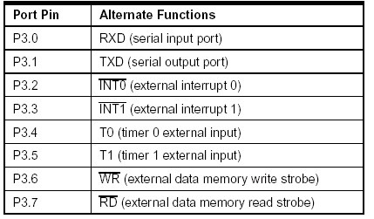
Table 2 – Port 3 Pin Details

XTAL1 – Pin 18

Input to the inverting oscillator amplifier and input to the internal clock operating circuit.

XTAL2 – Pin 19

Output of the inverting oscillator amplifier. Quartz crystal controlling the frequency commonly connects to these pins.

VCC – Pin 20
Supply voltage power +5v.

Port 2 – Pins 21 – 28

Port 2 is an 8-bit bidirectional I/O port with internal pullups. The Port 2 output buffers can sink/source four TTL inputs. If external memory is not present, pins of Port 2 act as universal input/output. If external memory is present, this is the location of the higher address byte, i.e. addresses A8 – A15. It is important to note that in cases when not all the 8 bits are used for addressing the memory (i.e. memory is smaller than 64kB), the rest of the unused bits are not available as input/output. When 1s are written to Port 2 pins, they are pulled high by the internal pullups and can be used as inputs. As inputs, Port 2 pins that are externally being pulled low will source current (IIL) because of the internal pullups. Port 2 emits the high-order address byte during fetches from external program memory and during accesses to external data memory that use 16-bit addresses (MOVX @ DPTR). In this application, Port 2 uses strong internal pull-ups when emitting 1s. During accesses to external data memory that use 8-bit addresses (MOVX @ RI), Port 2 emits the contents of the P2 Special Function Register. Port 2 also receives the high-order address bits and some control signals during Flash programming and verification.

PSEN – Pin 29

Program Store Enable is the read strobe to external program memory. When the AT89C51 is executing code from external program memory, PSEN is activated twice each machine cycle, except that two PSEN activations are skipped during each access to external data memory. Micro controller unit activates this bit (brings to low state) upon each reading of byte (instruction) from program memory. If external ROM is used for storing the program, PSEN is directly connected to its control pins.

ALE/PROG – Pin 30

Address Latch Enable is an output pulse for latching the low byte of the address during accesses to external memory. This pin is also the program pulse input (PROG) during Flash programming. In normal operation, ALE is emitted at a constant rate of 1/6 the oscillator frequency and may be used for external timing or clocking purposes. Note, however, that one ALE pulse is skipped during each access to external data memory. If desired, ALE operation can be disabled by setting bit 0 of SFR location 8EH. With the bit set, ALE is active only during a MOVX or MOVC instruction. Otherwise, the pin is weakly pulled high. Setting the ALE-disable bit has no effect if the microcontroller is in external execution mode. Before each reading of the external memory, Micro controller unit sends the lower byte of the address register (addresses A0 – A7) to port P0 and activates the output ALE. External register memorizes the state of port P0 upon receiving a signal from ALE pin, and uses it as part of the address for memory chip. During the second part of the mechanical MCU cycle, signal on ALE is off, and port P0 is used as Data Bus. In this way, by adding only one cheap integrated circuit, data from port can be multiplexed and the port simultaneously used for transferring both addresses and data.

EA/VPP – Pin 31

External Access Enable. EA must be strapped to GND in order to enable the device to fetch code from external program memory locations starting at 0000H up to FFFFH. Note, however, that if lock bit 1 is programmed, EA will be internally latched on reset. EA should be strapped to VCC for internal program executions. This pin also receives the 12-volt programming enable voltage (VPP) during Flash programming when 12-volt programming is selected. Bringing this pin to the logical state zero (mass) designates the ports P2 and P3 for transferring addresses regardless of the presence of the internal memory. This means that even if there is a program loaded in the MCU it will not be executed, but the one from the external ROM will be used instead. Conversely, bringing the pin to the high logical state causes the controller to use both memories, first the internal, and then the external (if present).

Port 0 – Pins 32 – 39

Port 0 can be used as an universal input/output port, if external memory is not used. If external memory is used, P0 behaves as address output (A0 – A7) when ALE pin is at high logical level, or as data output (Data Bus) when ALE pin is at low logical level. Port 0 is an 8-bit open drain bidirectional I/O port. As an output port, each pin can sink eight TTL inputs. When 1s are written to port 0 pins, the pins can be used as high impedance inputs. Port 0 can also be configured to be the multiplexed low order address/data bus during accesses to external program and data memory. In this mode, P0 has internal pullups. Port 0 also receives the code bytes during Flash programming and outputs the code bytes during program verification. External pullups are required during program verification.

GND – Pin 40
Ground.

Operating Description

The detail descriptions of the following IS89C51 blocks are described in this section.
- Memory Map and Registers
- Timer/Counters
- Serial Interface
- Interrupt System

Memory Map and Registers

Memory
The IS89C51 has separate address spaces for program and data memory. The program and data memory can be up to 64K bytes long. The lower 4K program memory can reside on-chip. Figure shows a map of the IS89C51 program and data memory. The IS89C51 has 128 bytes of on-chip RAM, plus numbers of special function registers. The lower 128 bytes can be accessed either by direct addressing or by indirect addressing. Figure shows internal data memory organization and SFR Memory Map. The lower 128 bytes of RAM can be divided into three segments as listed below and shown in Figure 7.

Register Banks 0-3: locations 00H through 1FH (32 bytes). The device after reset defaults to register bank 0. To use the other register banks, the user must select them in software. Each register bank contains eight 1- byte registers R0-R7. Reset initializes the stack point to location 07H, and is incremented once to start from 08H, which is the first register of the second register
bank.

Bit Addressable Area: 16 bytes have been assigned for this segment 20H-2FH. Each one of the 128 bits of this segment can be directly addressed (0-7FH). Each of the 16 bytes in this segment can also be addressed as a byte.
Scratch Pad Area: 30H-7FH are available to the user as data RAM. However, if the data pointer has been initialized to this area, enough bytes should be left aside to prevent SP data destruction.

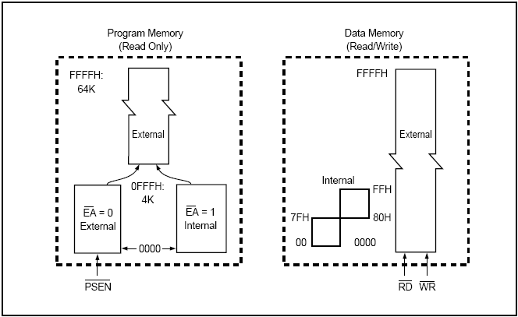
Figure 3 - Program and Data Memory Structure

SPECIAL FUNCTION REGISTERS

The Special Function Registers (SFR's) are located in upper 128 Bytes direct addressing area. The SFR Memory Map in Figure shows that. Not all of the addresses are occupied. Unoccupied addresses are not implemented on the chip. Read accesses to these addresses in general return random data, and write accesses have no effect. User software should not write 1s to these unimplemented locations, since they may be used in future microcontrollers to invoke new features. In that case, the reset or inactive values of the new bits will always be 0, and their active values will be 1. The functions of the SFRs are outlined in the following sections, and detailed in Table 2.

Accumulator (ACC)
ACC is the Accumulator register. The mnemonics for Accumulator-specific instructions, however, refer to the Accumulator simply as A.

B Register (B)
The B register is used during multiply and divide operations. For other instructions it can be treated as another scratch pad register.

Program Status Word (PSW). The PSW register contains program status information.

Stack Pointer (SP)
The Stack Pointer Register is eight bits wide. It is incremented before data is stored during PUSH and CALL executions. While the stack may reside anywhere in onchip RAM, the Stack Pointer is initialized to 07H after a reset. This causes the stack to begin at location 08H.

Data Pointer (DPTR)
The Data Pointer consists of a high byte (DPH) and a low byte (DPL). Its function is to hold a 16-bit address. It may be manipulated as a 16-bit register or as two independent 8-bit registers.

Ports 0 To 3
P0, P1, P2, and P3 are the SFR latches of Ports 0, 1, 2, and 3 respectively.

Serial Data Buffer (SBUF)
The Serial Data Buffer is actually two separate registers, a transmit buffer and a receive buffer register. When data is moved to SBUF, it goes to the transmit buffer, where it is held for serial transmission. (Moving a byte to SBUF initiates the transmission.) When data is moved from
SBUF, it comes from the receive buffer.

Timer Registers
Register pairs (TH0, TL0) and (TH1, TL1) are the 16-bit Counter registers for Timer/Counters 0 and 1, respectively.

Control Registers
Special Function Registers IP, IE, TMOD, TCON, SCON, and PCON contain control and status bits for the interrupt system, the Timer/Counters, and the serial port. They are described in later sections of this chapter.

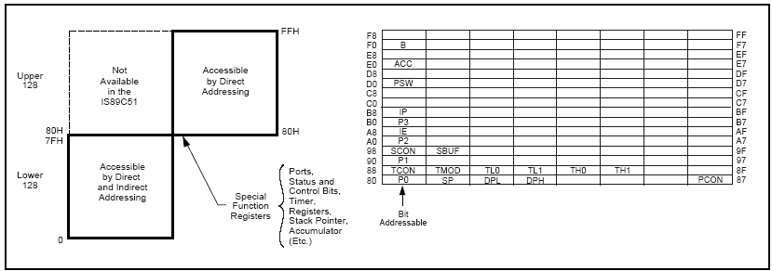
Figure 4 - Internal Data Memory and SFR Memory Map
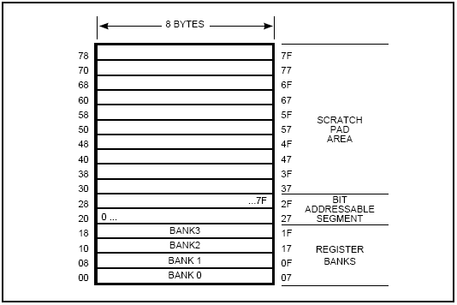
Figure 5 - Lower 128 Bytes of Internal RAM

TIMER/COUNTERS
The IS89C51 has two 16-bit Timer/Counter registers: Timer 0 and Timer 1. All two can be configured to operate either as Timers or event Counters. As a Timer, the register is incremented every machine cycle. Thus, the register counts machine cycles. Since a machine cycle consists of 12 oscillator periods, the count rate is 1/12 of the oscillator frequency. As a Counter, the register is incremented in response to a 1-to-0 transition at its corresponding external input pin, T0 and T1. The external input is sampled during

S5P2 of every machine cycle. When the samples show a high in one cycle and a low in the next cycle, the count is incremented. The new count value appears in the register during S3P1 of the cycle following the one in which the transition was detected. Since two machine cycles (24 oscillator periods) are required to recognize a 1-to-0 transition, the maximum count rate is 1/24 of the oscillator frequency. There are no restrictions on the duty cycle of the external input signal, but it should be held for at least one full machine cycle to ensure that a given level is sampled at least once before it changes. In addition to the Timer or Counter functions, Timer 0 and Timer 1 have four operating modes: 13-bit timer, 16-bit timer, 8-bit auto-reload, split timer.

Timer 0 and Timer 1
The Timer or Counter function is selected by control bits C/T in the Special Function Regiser TMOD. These two Timer/Counters have four operating modes, which are selected by bit pairs (M1, M0) in TMOD. Modes 0, 1, and 2 are the same for both Timer/Counters, but Mode 3 is different. The four modes are described in the following sections.

Mode 0:
Both Timers in Mode 0 are 8-bit Counters with a divide-by-32 prescaler. Figure 8 shows the Mode 0 operation as it applies to Timer 1. In this mode, the Timer register is configured as a 13-bit register. As the count rolls over from all 1s to all 0s, it sets the Timer interrupt flag TF1. The counted input is enabled to the Timer when TR1 = 1 and either GATE = 0 or INT1 = 1. Setting GATE = 1 allows the Timer to be controlled by external input INT1, to facilitate pulse width measurements. TR1 is a control bit in the Special Function Register TCON. Gate is in TMOD. The 13-bit register consists of all eight bits of TH1 and the lower five bits of TL1. The upper three bits of TL1 are indeterminate and should be ignored. Setting the run flag (TR1) does not clear the registers. Mode 0 operation is the same for Timer 0 as for Timer 1, except that TR0, TF0 and INT0 replace the corresponding Timer 1 signals in Figure 8. There are two different GATE bits, one for Timer 1 (TMOD.7) and one for Timer 0 (TMOD.3).

Mode 1:
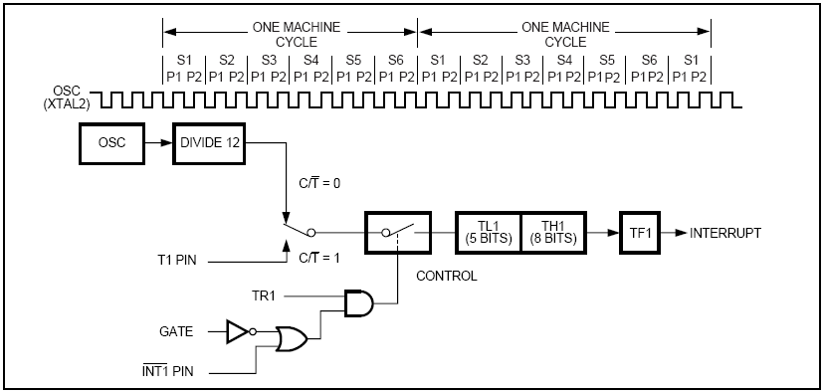
Figure 6 - Timer/Counter 1 Mode 0 : 13 – Bit Counter
Mode 1 is the same as Mode 0, except that the Timer register is run with all 16 bits. The clock is applied to the combined high and low timer registers (TL1/TH1). As clock pulses are received, the timer counts up: 0000H, 0001H, 0002H, etc. An overflow occurs on the FFFFH-to-0000H overflow flag. The timer continues to count. The overflow flag is the TF1 bit in TCON that is read or written by software.

Mode 2:
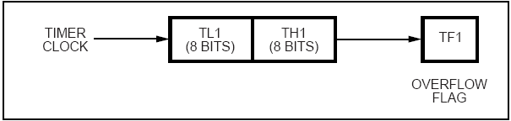
Figure 7 - Timer/Counter 1 Mode 1 : 16 –Bit Counter
Mode 2 configures the Timer register as an 8-bit Counter (TL1) with automatic reload, as shown in Figure 10. Overflow from TL1 not only sets TF1, but also reloads TL1 with the contents of TH1, which is preset by software. The reload leaves the TH1 unchanged. Mode 2 operation is the same for Timer/Counter 0.
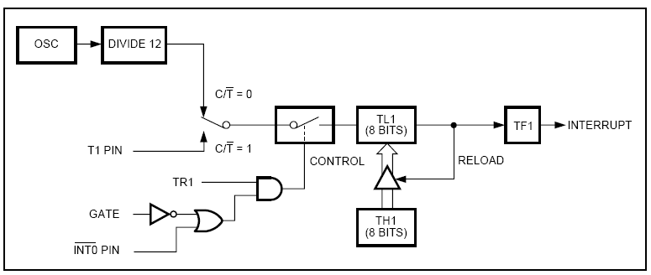
Figure 8 - Timer/Counter 1 Mode 2 : 8-bit Auto –Reload

Mode 3:

Timer 1 in Mode 3 simply holds its count. The effect is the same as setting TR1 = 0. Timer 0 in Mode 3 establishes TL0 and TH0 as two separate counters. The logic for Mode 3 on Timer 0 is shown in Figure 11. TL0 uses the Timer 0 control bits: C/T, GATE, TR0, INT0, and TF0. TH0 is locked into a timer function (counting machine cycles) and over the use of TR1 and TF1 from Timer 1. Thus, TH0 now controls the Timer 1 interrupt. Mode 3 is for applications requiring an extra 8-bit timer or counter. With Timer 0 in Mode 3, the IS89C51 can appear to have three Timer/Counters. When Timer 0 is in Mode 3, Timer 1 can be turned on and off by switching it out of and into its own Mode 3. In this case, Timer 1 can still be used by the serial port as a baud rate generator or in any application not requiring an interrupt.

INTERRUPT SYSTEM

The IS89C51 provides six interrupt sources: two external interrupts, two timer interrupts, and a serial port interrupt. These are shown in Figure 16. The External Interrupts INT0 and INT1 can each be either level-activated or transition-activated, depending on bits IT0 and IT1 in Register TCON. The flags that actually generate these interrupts are the IE0 and IE1 bits in TCON. When the service routine is vectored, hardware clears the flag that generated an external interrupt only if the interrupt was transition-activated. If the interrupt was level-activated, then the external requesting source (rather than the on-chip hardware) controls the request flag. The Timer 0 and Timer 1 Interrupts are generated by TF0 and TF1, which are set by a rollover in their respective Timer/Counter registers (except for Timer 0 in Mode 3). When a timer interrupt is generated, the on-chip hardware clears the flag that generated it when the service routine is vectored to.

The Serial Port Interrupt is generated by the logical OR of RI and TI. Neither of these flags is cleared by hardware when the service routine is vectored to. In fact, the service routine normally must determine whether RI or TI generated the interrupt, and the bit must be cleared in software. All of the bits that generate interrupts can be set or cleared by software, with the same result as though they had been set or cleared by hardware. That is, interrupts can be generated and pending interrupts can be canceled in software. Each of these interrupt sources can be individually enabled or disabled by setting or clearing a bit in Special Function Register IE (interrupt enable) at address 0A8H. As well as individual enable bits for each interrupt source, there is a global enable/disable bit that is cleared to disable all interrupts or set to turn on interrupts (see SFR IE).

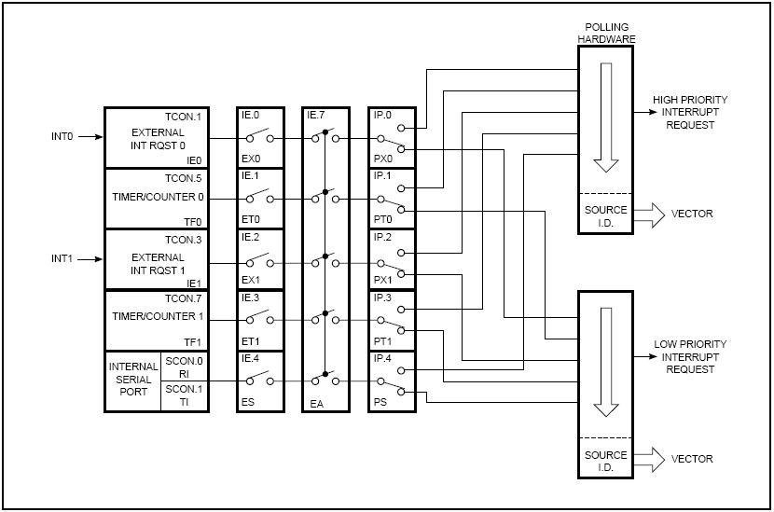
Figure 9 - Interrupt System

External Interrupts

The external sources can be programmed to be level activated or transition-activated by setting or clearing bit IT1 or IT0 in Register TCON. If ITx= 0, external interrupt x is triggered by a detected low at the INTx pin. If ITx = 1, external interrupt x is edge-triggered. In this mode if successive samples of the INTx pin show a high in one cycle and a low in the next cycle, interrupt request flag IEx in TCON is set. Flag bit IEx then requests the interrupt. Since the external interrupt pins are sampled once each machine cycle, an input high or low should hold for at least 12 oscillator periods to ensure sampling. If the external interrupt is transition-activated, the external source has to hold the request pin high for at least one machine cycle, and then hold it low for at least one machine cycle to ensure that the transition is seen so that interrupt request flag IEx will be set. IEx will be automatically cleared by the CPU when the service routine is called. If the external interrupt is level-activated, the external source has to hold the request active until the requested interrupt is actually generated. Then the external source must deactivate the request before the interrupt service routine is completed, or else another interrupt will be generated.

